Siddhanta Shiromani
Grahaganit adhyaya
Madhyamaadhikare Paridhyaadinirnayapakramah
(Section I, Chapter 7 : Determination of circumference of the earth)

Verse No | Translations
1 | It is said that the circumference of the earth is 4967 Yojanas and its diameter is 1581 Yojanas. If we subtract the latitudes of the two places situated north and south of each other, multiply that difference with the circumference of the earth and divide this product with 360 we can determine the distance between them in Yojanas.
2 | Multiplying the circumference of the earth by the RSine of the co-latitude of that place and dividing it by the radius (3438) we will have the corrected circumference of the earth. Else we can multiply the circumference of the earth by 12 and divide it by equinoctial hypotenuse (Visuvatkarna) we will have the corrected circumference of the earth.  Bimala Prasada Siddhanta Saraswati’s Note :  Subtracting the latitude of a place from 90° we will have its co-latitude. Visuvatkarna means the entrance of the sun in the equator and the hypotenuse of its shadow formed at the mid-day.  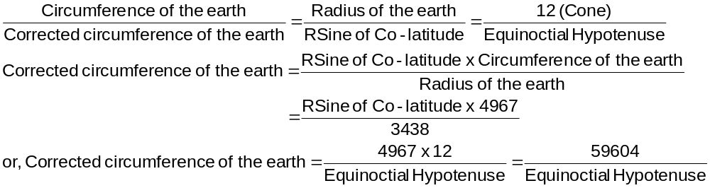
2 | The line that passes over Lanka and Ujjaini and touches the places like Kurukshetra and goes to the pole is named by the scholars as Prime Meridian of the earth.
3 | When we multiply the distance between the two places on the same latitude by the daily motion of a planet and divide the product by the corrected circumference of the earth we will have the result as the Deshaantara. If the place is to the east of the prime meridian we have to subtract the Deshaantara and if the place is to the west we have to add the Deshaantara to get the planetary position.  Bimala Prasada Siddhanta Saraswati’s Note :  Different places on the same latitude have different times of sunrise. We need the Deshaantara correction for determining the mean position of the planets at sunrise.  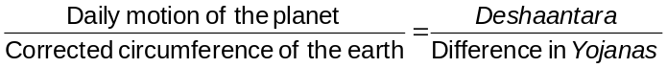

Verse No | Translations
4 | If a place lies to the east of the prime meridian then the eclipse will be seen at a later time than the time it would be seen in the prime meridian. If a place lies to the west of the prime meridian, it would experience the eclipse before the prescribed time at the prime meridian. The difference of time between the time of eclipse as seen along the prime meridian and the time of the same eclipse as seen from a particular place is called the Deshaantara of that place in time units.
5 | Multiplying this Deshaantara by the corrected circumference of the earth and dividing the product by 60 we will have the Deshaantara of that place in Yojanas. If the Deshaantara in time units be multiplied by the daily motion and divided by 60 we will have a result. If we add this result to or subtract this result from the planetary position we will get the Deshaantara corrected planetary position.  Bimala Prasada Siddhanta Saraswati’s Note :  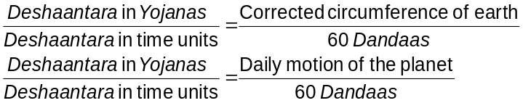  If the place be to the east of prime meridian the Deshaantara should be subtracted.
6 | If the place be to the east then the week-day begins after the local sunrise to the extent of Deshaantara in time units. If the place be at the west then the week-day begins before the sunrise at Lanka to the extent of Deshaantara in time units. Again if the sun be at the northern hemisphere, then the week-day would begin after and if the sun is in the southern hemisphere the week-day would begin before the time of the sun-rise at the prime meridian to the extent of half of the variation of a sidereal day from 30 Ghatiis (Chara).
7-8 | If we divide the number of elapsed years of an Aeon by 1200 we have a quotient. Again subtracting this quotient from 12000 we will have a difference. Now dividing the smallest of these two numbers (the quotient and the difference) by 200 we will have a result in minutes (Kalaas). We then multiply this result by 3, 5, 5, 15 and 2 individually and successively. We will then subtract the corresponding products from the positions of the Sun, Moon, Jupiter, Venus and apex of slowest motion of the moon respectively. Again we will take the result in minutes (Kalaas) and multiply it with 1, 52, 2 and 4 individually and successively. We will then add these results to the positions of Mars, Mercury, Node of the moon and Saturn. (This is called the Viijakarma)

Verse No | Translations
9 | This work can be made more voluminous by describing methods which are easy and interesting to unintelligent persons. But the learned people look down upon such work as indulging in unnecessary verbosity. We do not need a detailed exposition of them in this work. Hence I have briefly touched upon them.
10 | For the sake of clarity of exposition an intelligent man can make use of various methods like numerators, fractions having numerators and denominators mutually prime, various methods of interpolation and reduction and different numerators and denominators to get the desired results.
Hence ends the chapter named Madhyamaadhikare Paridhyaadinirnayapakramah
of Grahaganita part of Siddhanta Shiromani

Hence ends the section named Madhyamaadhikare of Grahaganita part of Siddhanta Shiromani

Bimala Prasada Siddhanta Shiromani’s note : According to Aryabhata the circumference of the earth is 1050 Yojanas (Aryasiddhantanuvada Page 3). According to Shri Surya Siddhanta the circumference of the earth is 1600 Yojanas (Page 9). According to Prof. Beschel the longest radius of earth is 3962.802 miles and the shortest radius is 3949.555 miles (see Golaadhyaya Page 34).
The hypotenuse of the right angled triangle formed by the cone and the equinoctial mid-day of it.
Bimala Prasada Siddhanta Shiromani’s note : According to Shri Surya Siddhanta (translator’s note : here he quotes Sanskrit Verse no 62 Chapter 1 from Sri Surya Siddhanta whose translation I give as follows) The line that passes through the Demons’ haunt and the mountain of the Gods (Mount Sumeru), on which there are cities like Rohitaka and Avanti (Ujjain), is the prime meridian (Madhyarekha). The scholars have determined Ujjaini to be situated at the terrestrial longitude 75°52’E of London and latitude 23°11’. According to them Rohitaka is situated at the terrestrial longitude 76°38’ E of London and latitude of 28°54’. We mean a place on the equator by the word Lanka. (See Golaadhyaya page 57).
Bimala Prasada Siddhanta Shiromani’s note : Lunar eclipse is seen at the same time all over the earth. This is because the lunar eclipse occurs when the shadow of earth falls on that of the moon. But owing to the difference in longitude this eclipse is seen at different times after the sunset.
Bimala Prasada Siddhanta Shiromani’s note : The week-day begins with the sun-rise at Lanka. If the place is to the east of the prime meridian then its week-day will start exactly after the Dandaas of the Deshaantara. But we need to do a half of the variation of a sidereal day from 30 Ghatii (Chara) correction in the time of its sunrise to account for its latitude. Bhaskara has specified this correction for the places of the northern hemisphere in a way, which is to be applied in the reverse order for the places in the southern hemisphere.

